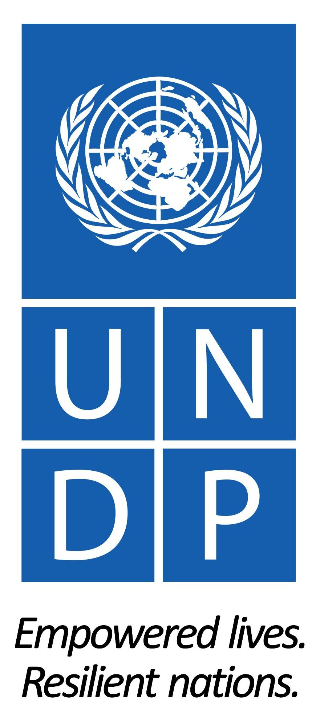
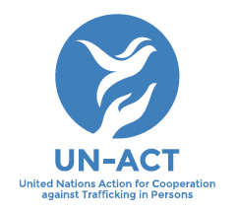

UN-ACT

UN Action for Cooperation against Trafficking in Persons

Annual Progress Report 2018

Executive Summary

While 2018 was a transitional phase for UN-ACT, programming continued and was extended through until mid-2020 due to provision of further financial support and continued need for the project. The project extension until 2020 means UN-ACT can continue to address the still apparent necessity for coordination of anti-trafficking both through the COMMIT process and more broadly through the promotion of multi-sector partnerships. UN-ACT continues to provide support to COMMIT as Secretariat to the Process, providing independent coordination and technical support to governments so they can enhance the regional response to trafficking in persons. However, the establishment of the COMMIT Chair, rotating between the countries, and the financial support that the countries are providing to activities have resulted in it reaching a high degree of independence and sustainability.
The project will also continue to deliver on its core activities relating to the implementation of the fourth COMMIT Sub-regional Plan of Action (SPAIV), centrally focusing on the catalytic initiative on (Trans)National Referral Mechanisms (TNRM) to ensure more trafficked persons receive rights-based support tailored to their needs. This has received dedicated financial support, as well as cost-sharing by partners (both government and non-government) and a strategic plan for its longer-term sustainability.
Over 2018, UN-ACT also sought to use the experiences, networks, and lessons learned from the project – as well as the growth of UNDP’s own work on migration and displacement – to evolve the project into a new initiative on broader issues related to human trafficking and mixed migration. The Development Approaches to Migration and Displacement (DMD) was developed and agreed within UNDP Bangkok Regional Hub as the way forward in this area. This initiative provides a comprehensive and holistic response to migration and displacement, including within this a development centred response to addressing human trafficking. The initiative is being piloted in three countries by the end of 2018 and it is hoped to expand further in 2019.
Toward the end of 2018, UN-ACT moved to deliver its commitments primarily through National Project Coordinators and a streamlined regional coordination architecture. The implementation of activities throughout the period has relied on working through innovative cost-sharing models to adapt to budgetary constraints while continuing resource mobilisation efforts.

- Strengthening the COMMIT Process

Sustainability: 2018 has been a significant year in moving towards a sustainable, self-reliant COMMIT. Though UN-ACT retains a core role as COMMIT secretariat – providing technical and coordination support where required – member governments have increasingly taken responsibility for co-financing and delivering on COMMIT objectives. The establishment of a rotating COMMIT chair has helped with the transfer of secretariat functions to members, with 8 secretariat function fully transferred and 9 partly transferred to government counterparts in 2018. Besides, transferring function, cost-sharing on activities and a direct financial contribution of USD150,000 over two years to UN-ACT from the Chinese government are paving the way for longer-term process sustainability.
Sub-regional Plan of Action IV (SPAIV) Implementation: UN-ACT continued its support for the implementation of the SPA IV across the four areas of prevention, prosecution, policy and protection. Key results in SPA-IV implementation came mostly in the area of protection, as a consequence of UN-ACT catalytic initiative on (T)NRM. Governments have agreed to a step-phased approach to developing the (T)NRMs in each of the countries, together with an alliance of partners, coordinated by UN-ACT. Capacity mapping and budget advocacy exercises for all COMMIT country members and three multi-stakeholder National Consultations were conducted (two in Cambodia and one in Lao PDR), with 6 more likely to be conducted in 2019, between government and non-government agencies, who will be involved in the NRMs. An agreement on the structure and services within the NRM is anticipated to result, along with the steps and protocols required to ensure referrals are successfully supported.
Cooperation Beyond COMMIT
Extra-sub-regional and ASEAN Cooperation: UN-ACT is working closely with other partners – including ASEAN – and other extra-regional partners are collaborating with COMMIT members as a result of UN-ACT support. UN-ACT has continued to engage other regional actors, emphasising partnership with other international development agencies and prioritizing cooperation with ASEAN countries of destination for GMS country migrants. Though still informal, UN-ACT has enhanced cooperation with ASEAN through regional level platforms to align COMMIT and ASEAN agendas, and ensure UN-ACT can share lessons learned with the broader ASEAN community. Beyond East Asia, UN-ACT Vietnam supported the development and signing of an MoU between Vietnam and United Kingdom on trafficking.
- Strengthening the Knowledge-base for Anti-trafficking
Research Production and Dissemination: In 2018, UN-ACT continued to serve as an important platform for the production and dissemination of research to ensure evidence-based response to human trafficking. The UN-ACT website received 15,325 visitors, of which 85% of these were new and 15% returning. UN-ACT also continued to draw upon its research portfolio and role as Secretariat to the COMMIT Process to inform the discussions and decision-making on counter-trafficking in the sub-region. During the reporting period, the project was chiefly involved in 3 key publications in partnership with UN and academic partners, namely ‘Thailand Migration Report’, ‘Irregular Migrants, Refugees or Trafficked Persons?’ and ‘What’s the incentive? Comparing regular and irregular migrant work experiences from the Lao People’s Democratic Republic to Thailand’. These directly supported UN-ACT’s efforts to broaden the discourse on human trafficking and embed the phenomenon more adequately in its structural context including migration governance. In fact, ‘What’s the incentive?’ directly supported COMMIT’s work on strengthening labour migration systems as agreed unanimously at COMMIT SOM 11 as a key priority for the Process’ work. Further, ‘Irregular Migrants, Refugees or Trafficked Persons’ was a key contribution to the evolving recognition of the complexities in migratory categories, and the need to extend support to migrant populations beyond such narrowly defined groups as trafficked persons. It also intended to engage the academic community in the region more in the discourse on migration – a process which has continued into 2019 with ongoing collaborations between Mahidol University, the Royal Thai Government, UN-ACT and IOM on development approaches to migration and displacement. UN-ACT’s work on the intersections of migratory categories is also continuing with a report on vulnerabilities to abuse and exploitation of urban refugees in Bangkok to be launched jointly with Mahidol University and the Center for Asylum Protection in 2019. The sustainability of UN-ACT’s research is impacting through the COMMIT Process, informing protection and prevention interventions. It is also spreading out to partners’ initiatives, both in counter-trafficking and broader mixed migration, which we will seek to better assess in 2019. The longer-term sustainability will likely be contingent on resource mobilization efforts for the Development Approaches to Migration and Displacement Initiative, discussed below, and how this can embed UN-ACT’s strategy and data collection approaches throughout the migration cycle.

Enhancing Civil Society, Private Sector and Academia’s Contribution to Anti-Trafficking
Civil Society: UN-ACT worked through 2018 to re-evaluate and strengthen national and regional platforms for civil society to engage with governments. This included engagement with civil society partners around re-design of the formal participation platform in COMMIT but given the delay in the Senior Officials Meeting this remained in a planning stage. UN-ACT continued to provide a platform for regional civil society coordination and partnership development through Regional Network Meetings, co-hosted with partners such as ILO. At national level, UN-ACT country offices enhanced the role for civil society where partnerships between governments exist and worked to sensitise governments to the potential of civil society across the region. This continued to work well in Cambodia and Thailand, yet hindered in China and Myanmar, with incremental progress in Lao PDR and Vietnam.
The Private Sector: Though engagement with the private sector remained ad-hoc through 2018, UN-ACT has worked to establish connections with private sector partners and contribute to initiatives focused on strengthening private sector awareness of and response to human trafficking. UN-ACT met with a number of private sector stakeholders – including Facebook, Jones Day, IKEA, and the Japan Business and Human Rights Advocacy group – as well as contributing to initiatives on Business and Human Rights.

Introduction: Situation Analysis on Human Trafficking in the GMS
Trafficking in persons constitutes one of the worst forms of human rights abuses, whereby individuals are severely exploited through means of deception, coercion, or force. From the trade in infants and organs, to marriage trafficking or severe forms of labour/sexual exploitation, human trafficking is a complex and dynamic phenomenon affected by multiple, intertwined factors including socio-economic disparities, weak governance systems, gender inequalities, as well as limited labour rights and migration opportunities.
The Asia-Pacific region records by far the highest rates of trafficking in persons worldwide, with a prevalence three times greater than the second most affected region, namely Africa. Within the Asia-Pacific region, the GMS features some of the most extensive flows, characterized by strong cross-border patterns due to such factors as traditional migration trends, long and porous borders, significant socio-economic imbalances, and cultural linkages.
In 2018, trafficking for forced marriage in China continued to draw attention of governments. It constituted an increasing trend in Lao PDR and Cambodia as well as one of the main causes of cross-border human trafficking in Myanmar, the primary source country for victims of trafficking in the region. Increasingly, anti-trafficking actors have drawn attention to the growing prevalence of surrogacy – generally involving women from Cambodia, Vietnam, Myanmar carrying babies for people in China – and an increase in trafficking for this purpose.
Over the past five years, partnerships to address human trafficking and the capacity of government agencies and civil society to respond to human trafficking have developed markedly, especially in the area of prosecution and policy. However, progress has been slower in the area of protection and support services for trafficked persons. UN-ACT programming has aimed to address this shortfall, through programs that help governments and other stakeholders work together to put human rights and the needs of trafficked persons at the centre of anti-trafficking responses, while also augmenting the role of civil society.
Introduction: UN-ACT and Responses to Trafficking
UN-ACT is a regional project of UNDP with offices across the Greater Mekong Sub-region countries, namely Cambodia, China, Lao PDR, Myanmar, Thailand and Viet Nam. Working to counter human trafficking in all its forms, UN-ACT aims to build the capacities of governmental agencies, civil society, academic institutions and the private sector. It also facilitates coordination and cooperation among all relevant stakeholders to work in a mutually supportive manner to effectively combat trafficking. Key to UN-ACT’s work is its support to COMMIT, a government-led, multi-stakeholder process between the GMS countries, established in 2004 to jointly counter human trafficking in the sub-region. In addition, UN- ACT seeks to address patterns of human trafficking that go beyond the COMMIT countries through work with extra-sub-regional partners. UN-ACT also aims to increase evidence-based research on trafficking issues and conducts research in-house and in collaboration with other institutions.
Results
Outcome: Key anti-trafficking stakeholders in the region are working in a more cooperative and mutually supportive manner to effectively combat trafficking in persons
Anti-trafficking stakeholders in the region – particularly government agencies – are working together more effectively to combat human trafficking as a direct and indirect result of UN-ACT’s work across areas of prevention, prosecution, protection, and policy. At intergovernmental level, there are now bilateral cooperation mechanisms guiding the management of human trafficking cases between 10 of the 15 bilateral relationships in the GMS. For all but two of these, implementation mechanisms – in the form of Plans of Action and/or joint Standard Operating Procedures are either in place or being drafted. Within countries, there are better partnerships amongst government agencies, stimulated by National COMMIT Task Forces, which are working to bring responses to trafficking in line with international standards. Since 2014, 11,544 trafficked persons have been referred to protection and support services, and 57 positive policy changes have come as a result of multi-stakeholder advocacy.
UN-ACT’s contribution to these improvements has come primarily through supporting COMMIT members to:
- Develop, agree, and collectively commit to shared policy and standards for practice on protection and support services for trafficked persons
- Create and/or strengthen bilateral cooperation mechanisms – through Memoranda of Understandings (MoU), joint Plans of Action (PoA) and Standard Operating Procedures (SOP) – that operationalise regional commitments in specific bilateral contexts
- Tailor and implement shared policy and standards at country level, through ongoing support to National Anti-trafficking Taskforces in National Plan of Action development and implementation.
In 2018, at least 1,589 trafficked persons were referred and supported through national and transnational referral mechanisms. There were also 17 positive changes in policy that came as a result of multi-stakeholder advocacy. In 2018, UN-ACT’s contributions were most apparent in the area of protection, with GMS governments taking practical steps towards the development of NRMs – notably capacity development and mapping, budget advocacy, and national consultations involving various government agencies and CSOs – as part of UN-ACT’s catalytic initiative on (T)NRM. This initiative is already stimulating improvements and providing tools being used by frontline service providers to improve the reach and quality of support and protection for trafficked persons (see. Act. Results 1.3.). UN-ACT took a strategic decision to focus on the NRM catalytic initiative due to resource limitations and the relative lack of progress on protection as compared with prosecution and policy, and this initiative will be the primary focus of UN-ACT’s efforts going forward into 2019.
Besides protection, progress has been made in prosecution, with the Chinese government spearheading a Joint Special Investigation Initiative – through partnerships established through the COMMIT Process – with law enforcement agencies across the GMS.
2018 also brought key results in enhancing the ownership of the COMMIT process with the transfer of some responsibility for financing and coordinating over to government stakeholders, demonstrating member states commitment to mutually support each other’s efforts and the COMMIT process (see. Output 1 and Act. Results 1.2.).
Gaps in the knowledge base for regional policy on human trafficking – specifically related to forced marriage, categorisation of migrants, and labour migration between Lao PDR and Thailand – were also addressed in 2018, through the production and strategic dissemination of research by UN-ACT, in partnership with NGOs and other UN agencies (see Act. Results 3.1 and 3.2).
Output 1: The COMMIT Process is strengthened to become sustainable and self-reliant
2018 has been a significant year in moving towards a sustainable, self-reliant COMMIT. Though UN-ACT retains a core role as COMMIT secretariat – providing technical and coordination support where required – member governments have increasingly taken responsibility for co-financing and delivering on COMMIT objectives. The establishment of a rotating COMMIT chair has helped with the transfer of secretariat functions to members, with 8 secretariat function fully transferred and 9 partly transferred to government counterparts in 2018. Besides, transferring function, cost-sharing on activities and a direct financial contribution of USD150,000 over two years to UN-ACT from the Chinese government are paving the way for longer-term process sustainability.
Activity Result 1.1: COMMIT accountability and transparency enhanced
UN-ACT has worked with COMMIT governments to enhance accountability, together undertaking to improve progress reporting for greater transparency and collective learning.
- 5 GMS governments – all except China – reported on COMMIT Process M&E SPAIV indicators they had agreed to in 2018.
- COMMIT governments agreed to conduct evaluations in line with COMMIT priorities for 2018 in preparation for SOM13 – emphasising the need for a move away from listing activities and toward a focus on challenges faced, lessons learnt and recommendations to help COMMIT move forward more effectively and transparently.
- At national level, UN-ACT National Project Coordinators (NPCs) have worked with government counterparts to ensure progress is reported and challenges identified so that ways of overcoming them can be developed. For example, in Cambodia, the of Cambodia’s COMMIT Taskforce work has been enhanced through a series of meetings with UN-ACT, including two to review progress, challenges and lessons learnt from 2017. These were then integrated into the National Strategic Plan for 2019-2023.
Activity Result 1.2: Sufficient technical and functional capacities developed by governments
COMMIT governments solidified steps made in 2017 to take on many the COMMIT secretariat functions themselves as part of the strategy to have the COMMIT governments, with 2018 seeing 8 secretariat function fully transferred and 9 partly transferred to government counterparts. Governments collectively took steps to enhance ownership and sustainability of COMMIT, agreeing upon the establishment of a rotating COMMIT chair responsible for the hosting of Senior Officials Meetings. It was agreed that China would be the first chair for SOM13 – held in early 2019 – and informally agreed that that Vietnam would chair SOM14 – to be held in 2020. This ensures that COMMIT Process members will have a forum comprising a broad range of stakeholders at which to report on progress made against the SPAIV for the coming two years.
At national level, UN-ACT worked with governments to build capacity through assistance in the development and implementation of national anti-trafficking strategies as well as targeted trainings for front-line practitioners.
Key results:
- The government of Cambodia developed a new National Strategic Plan on TIP (2019-2023). UN-ACT worked closely with the Ministry of Women’s Affairs, who chair the COMMIT Task Force, and through the International Cooperation Technical Working Group (ICTWG) to ensure the National Strategic Plan on TIP (2019-2023) reflected international standards, especially in the areas of repatriation, right to remain, and rights to work.
- In Cambodia, capacities of 76 government official – 25 women and 51 men – were increased through training on national human trafficking laws, the National Strategic Plan on TIP (2014-2018) and policies for the national gendarmerie, with support from UN-ACT’s Cambodia NPC.
- The Myanmar Central Body for the Suppression of TIP National M&E Group – formed in 2017 – drafted a Results and Resource Framework to ensure comprehnesive monitoring and evaluation (M&E) of NPA 2017-2023 implementation. UN-ACT provided technical assitance through training on M&E and results-based management at two meetings supported by UN-ACT and other partners. The M&E Group are working to assign roles and responsibilities among member departments and select focal points to complete the approved M&E framework, and UN-ACT will continue to support their work into 2019.
- The Government of Vietnam improved law enforcement officers’, social workers’ and health professionals’ knowledge of child exploitation, anti-trafficking laws, and national procedures. UN-ACT – in collaboration with NSPCC and government partners – organized six participatory trainings held in Northern, Central and Southern province of Vietnam with 205 front-line practitioners – 51 women and 154 men. According to the training evaluation, participants had better knowledge of child exploitation and trafficking; relevant definitions, legislation and procedures. Participants were better able to identify the vulnerabilities of children and signs of child exploitation and trafficking.
- UN-ACT also partnered with the Ministry of Public Security (MPS) of Vietnam and NSPCC to co-organize a professional forum focused on enhancing responses to child trafficking. Sixty-five participants came from relevant ministries, the national COMMIT Task Force, key provinces, international agencies, embassies and media. The workshop identified a number of limitations in responses to child-trafficking – shortages of facilities for the victim accommodation at border guard stations, lack of counselling skills when working with child victim, the low support allowance which impedes victim recovery and sustainable reintegration, and weak coordination among relevant actors. Participants worked to device solutions to better support child victims, such as strengthening communication campaign on anti-trafficking, building capacity for frontline responders on working skills with child victims, efficient cooperation among relevant actors to support victim and encouraging the involvement of CSOs. UN-ACT Vietnam will continue to follow up on with partners in 2019.
Activity Result 1.3: Effective implementation of SPA IV
‘UNACT plays an important role in bringing policies developed at reginal level to practical implementation at the country level. UNACT also provides good direction and guidance for COMMIT countries in identifying joint priorities for each year which fit into the regional context.’ - Official of the Department for Criminal Investigation Police, Ministry of Public Security, Vietnam.
UN-ACT continued its support for the implementation of the SPA IV across the four areas of prevention, prosecution, policy and protection. Given resources limitations, however, 66% of COMMIT workplan activities were completed across the region. UN-ACT advocated for the prioritisation of policy/cooperation and protection through initiatives we could most closely influence.
- At least 1,589 trafficked persons were referred and supported through national and transnational referral mechanisms. UN-ACT supported the development of these mechanisms in line with Outcome 4.2 of SPAIV throughout 2018 to ensure more trafficked persons receive assistance. Towards this end, the catalytic initiative on NRMs involved the 6 capacity building and mapping exercises, 6 budget advocacy exercises, and 3 national consultations. 6 more consultations are planned for 2019. By the end of 2019 it is expected that 4 strengthened NRM frameworks will be finalised and rolled out through training in the first half of 2020.
- At this regional level, one new MoU – between China and Thailand was signed – and drafting of two SOPs is underway. UN-ACT continued to support the development of bilateral and multilateral anti-trafficking cooperation through a review of bi- and multilateral MoUs, agreements, Plans of Action, and SOPs in the region aimed at assessing their suitability for serving as the basis for a Regional TRM. Moreover, UN-ACT provided ongoing technical assistance to government counterparts drafting and implementing agreements to help them place considerations of human rights and trafficked person’s needs at the centre of their centre of cooperation mechanisms.
Key progress was made in the development of National Referral Mechanisms:
- The development of the NRM in Cambodia is progressing well with buy-in from Ministry of Social Affairs, Veterans and Youth Rehabilitation (MoSAVY) and Ministry of Women’s Affairs (MoWA), and good collaboration with other agencies – including NGOs – following two national consultation workshops supported by UN-ACT. The workshop identified a number of strengths with existing frameworks for referrals in Cambodia, but also found a number of areas that require significant improvement, especially in the delivery of services to – and protection of – trafficked persons. A lack of sensitivity to various specific needs of migrants – i.e. a lack of individual needs assessments – was noted. The results of the workshop informed the drafting the NRM structure and UN-ACT will continue to work closely with the Cambodian government as they develop and implement the framework. Drafting is likely to be completed by Q3 2019, and trainings for law enforcement and service providers will commence in the first half of 2020.
- Besides the National Consultations, the Cambodian Department of Anti-Human Trafficking and Victim Reintegration – in partnership with UN-ACT – is developing a national victim database, with a review of the existing data management framework conducted by a consultant and a workshop convened to provide recommendations for the new system. This initiative has been put on hold due to a lack of funding but the the Department of Anti-Human Trafficking and Victim Reintegration of MoSAVY is engaged in ongoing resource mobilization efforts that will extend into 2019.
- The Lao Women’s Union (LWU) are drafting an NRM structure in Lao PDR and have held two national consultations, which UN-ACT contributed to, to understand referral practices of other agencies and organizations. UN-ACT has worked with partners – IOM, Winrock and UNICEF – to support the LWU in developing the NRM, placing specific emphasis on aligning it with COMMIT guidelines on victim ID and NRMs as well as ensuring participation of civil society. The LWU intend to have the improved NRM structure drafted by the middle of 2019. UN-ACT will support this, and subsequent trainings to implement the new framework toward the end of 2019 and into 2020.
- The MPS of Vietnam co-hosted a national consultation workshop on National Referral Mechanism to support trafficked victims, engaging 67 representatives – 30 women and 37 men – from central and provincial government partners, UN agencies, international organizations and CSOs. The workshop involved experience-sharing on case referral to map the foundations for NRM development in Vietnam. UN-ACT have been working with MPS to draft a policy brief based on this consultation.
- Moreover, the Ministry of Labour, Invalids and Social Affairs (MoLISA) published guidelines on referral to support trafficked victims, a directory of supporting services and leaflets on victim’s rights – for all of which UN-ACT provided important inputs. To ensure practitioners and officials were socialised to these documents, MoLISA organized has organized trainings and workshops for practitioners.
- The Ministry of Social Development and Human Security (MSDHS) of the Royal Thai Government have worked to map and improve their referral processes, which are already the most advanced in the region.
- In all the COMMIT countries, UN-ACT has worked with government partners throughout 2018 to develop briefs to be used internally for budget advocacy to ensure NRM sustainability. This initiative has been well-received by most governments and will run into 2019 with the aim of securing regular budget contributions from governments for NRMs.
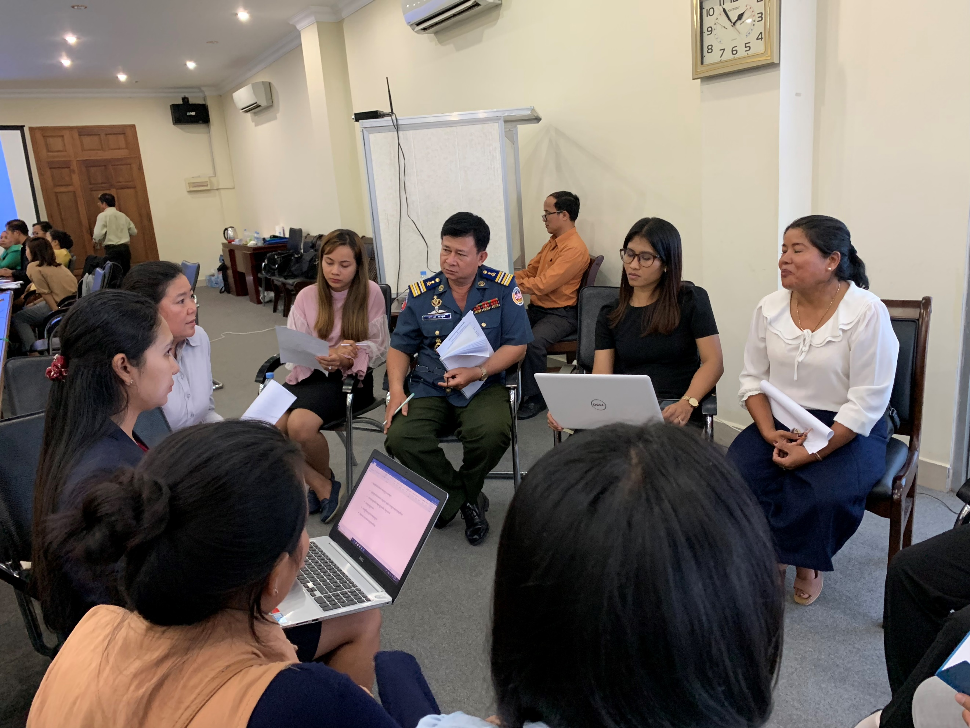
Photo: Consultation on the National Referral Mechanism development in Cambodia
Key results on bilateral cooperation mechanisms:
- Key ministries in China and Thailand offices are working more closely together together to support responses in victim identification, assistance to trafficked persons, repatriation and ultimately seeking justice in cases in light of emergent trafficking patterns between China and Thailand, including through deception through social media into sexual exploitation. This is as a result of the signing of MoU between China and Thailand in Nov. 2018, following persistent advocacy by CSOs in both countries as well as UNACT. The signing event was supported by the Government of China, with UN-ACT working closely with the Governments on throughout the process. The two countries will be developing a joint Plan of Action to implement the MOU, which UN-ACT China and Thailand country office will continue to support.
- The Bilateral Meeting for the 2nd Review of the Memorandum of Understanding (MOU) between the Government of the Kingdom of Thailand and the Government of the Republic of the Union of Myanmar on Cooperation to Combat Trafficking in Persons was held on 9 August 2018 in Yangon, Myanmar, with UN-ACT country offices providing support to government counterparts. The two delegations successfully reached agreement on all provisions of the draft MOU. The final agreed text of the draft MOU as negotiated was initiated by the heads of the delegations and the actual date and venue of the MOU Signing Ceremony are to be communicated to each other through diplomatic channels.
- The MoSAVY of Cambodia and the MSDHS of Thailand have made significant progress towards signing a Standard Operating Procedures (SOP) for victim identification and repatriation, with technical and coordination support from UN-ACT. As of the end of 2018, the SOP was being drafted – with UN-ACT support – with the expectation from government’s that it would be signed in April 2019.
- Myanmar and Thailand strengthened case-by-case cooperation and shared knowledge on case management through the 22nd THA-MMR Case Management Meeting, hosted by MSDHS of Thailand on 11 December 2018 in Bangkok, Thailand. UN-ACT Thailand NPC supported the Thai government with preparations for presentations at the CMM and acted as resource person on the day of the meeting. The meeting also involved a shelter visit attended by Myanmar officials to learn from MSDHS shelter management practices. The CMMs are testament to the comprehensive implementation of the MoU between the two governments, which is identified as an exemplary in UN-ACT’s upcoming review of bilateral agreements in the GMS. The third CMM will be held in August 2019.
- UN-ACT facilitated the Myanmar Delegation’s participation in the Workshop on Law Enforcement & Victim Protection Coordination to Disrupt Human Trafficking organized by UNODC and UN-ACT/UNDP in Hanoi, Vietnam on 12 June 2018.
- With UN-ACT’s support, Cambodian and Chinese officials met in May 2018 to review the progress made since the last annual review meeting in March 2017 in China, and to discuss the development of a joint action plan between the two governments on strengthening cooperation in preventing and combatting trafficking in persons. The meeting played a key role in the decision of the Chinese government to pilot a project in one of the top destinations in China for forced marriage victims from Cambodia, aimed at improving identification and protection of victims.
- A Joint Special Investigation Initiative was conducted – led by the Chinese MPS – police in six countries between July and December last year conducted a special campaign to target the abduction and trafficking of women in the border areas. During the drive, police uncovered 760 abduction and marriage fraud cases and rescued 1,130 foreign women and 17 children. UN-ACT provided communication and case referral as well as interpretation support to the authorities to help them provide qualified interpretation to the vulnerable and potential victims. While not formally a COMMIT initiative, government officials credited communications channels established through COMMIT as invaluable to this initiative.
Output 2: COMMIT countries increase their cooperation with other countries and regional actors to effectively counter human trafficking
‘UN-ACT is considered as a strong coordination mechanism and a good model, helping not only the countries in the Great Mekong Subregion, but also other countries outside the region to work together with us to fight against trafficking in persons… Through UN-ACT’s coordination, Cambodia has been able to cooperate with China and Malaysia for mutual assistance in assisting Cambodia victims.’ - Director of Legal Protection Department, Ministry of Women’s Affairs, Cambodia
UN-ACT has continued to consistently engage regional stakeholders, emphasising partnership with other international development agencies and prioritizing cooperation with ASEAN and countries of destination for GMS country migrants. Though still informal, UN-ACT has enhanced cooperation with ASEAN through regional platforms with the aim of aligning COMMIT and ASEAN agendas and ensuing UN-ACT can share lessons learned from the GMS with the broader ASEAN community.
Activity Result 2.1: Joint anti-trafficking efforts of COMMIT countries with key destination countries elsewhere increased
- UN-ACT Vietnam supported the development and signing of an MoU on anti-trafficking between Vietnam and United Kingdom – an important country of destination for Vietnamese migrants.
- The UN-ACT Cambodia office assisted the government prepare for bilateral meeting between Cambodia and Malaysia on 27-29 April 2018 in Malaysia. The inputs and comments were collected and integrated into the draft MoU (the bilateral meeting was postponed).
Activity Results 2.2: Institutionalized engagement between COMMIT and ASEAN
- UN-ACT RMO took part in an ASEAN+3 table-top exercise, organized by SOM-TC for Law Enforcers and Prosecutors to Enhance Cross-Border Joint Investigations and Operations on Trafficking in Persons Related Cases. Mr. Paul Buckley facilitated a session on Possible Areas of Collaboration – briefing on COMMIT and sensitising ASEAN counterparts to UN-ACT’s results-based, multi-disciplinary approach.
- UN-ACT participated in the ASEAN Intergovernmental Commission on Human Rights (AICHR) Regional Workshop on Prevention Strategies to combat Trafficking in Persons (TIP), Especially Women and Children: Enhancing Access to Information and Community-based Protection System, which provided an avenue for 60 participants from different regional and international organizations and groups to discuss on the international and regional legal and policy frameworks on anti-TIP, especially women and children, the human rights-based, people-centred and multi-stakeholder approach in the development and implementation of TIP prevention strategies as well as challenges and the ways forward to enhance regional cooperation on the agenda. Following up on this, UN-ACT provided feedback on ASEAN concept notes and promoted cooperation between UNDP Vietnam and AICHR.
- UN-ACT delivered a technical presentation and participated in the ASEAN Commission on Women and Children Strategic Planning Workshop on the Nexus between trafficking and VAW in December 2018.
- UN-ACT RMO supported UN-ASEAN collaboration, submitting inputs for a UN-AICHR meeting at the ASEAN Secretariat, Jakarta, elaborating the development of national and transnational referral mechanisms for trafficking cases in the region.
Activity Result 2.3: Coordination and cooperation among relevant regional actors for anti-trafficking increased
- UN-ACT RMO provided technical support to capacity building for Interpol national focal points and the Global Innovation centre on international law related to human trafficking and smuggling, UN-ACT's work and the COMMIT Process.
- UN-ACT RMO participated in a two-day consultative dialogue held to discuss the ‘Safe and Fair: Realizing women migrants worker’s rights and opportunities in the ASEAN region’ project, being implemented across ASEAN countries with support from ILO, UN Women, and the US.
- UN-ACT RMO served as resource person for the UNODC workshop on ‘Smuggling Migrants, Trafficking in Persons and Corruption: Strengthening Information Sharing and Cooperation’, providing inputs on the nexus between corruption and human trafficking.
- Promoting regional learning on reintegration for trafficked persons, UN-ACT supported and facilitated the Cambodian delegation composed of government officials and CSO staff to attend a JICA regional workshop in March 2018 on reintegration and a UNODC workshop on corruption and migrant smuggling held in April.
Output 3: Policy makers, academia, non-state actors and the public have increased access to evidence-based research and knowledge on human trafficking
‘UNACT as the co-chair of the counter-trafficking network in Vietnam plays an important role in bringing all relevant stakeholders together… UNACT is a source of information and connection that anyone who needs information on trafficking can refer to.’ – Country Programme Coordinator, ASEAN-Australia Counter Trafficking Project, Vietnam

In 2018, UN-ACT continued to serve as an important platform for the production and dissemination of research to ensure evidence-based response to human trafficking. The UN-ACT website received 15,325 visitors, of which 85% of these were new and 15% returning. UN-ACT also continued to draw upon its research portfolio and role as Secretariat to the COMMIT Process to inform the discussions and decision-making on counter-trafficking in the sub-region. During the reporting period, the project was chiefly involved in 3 key publications in partnership with UN and academic partners, namely ‘Thailand Migration Report’, ‘Irregular Migrants, Refugees or Trafficked Persons?’ and ‘What’s the incentive? Comparing regular and irregular migrant work experiences from the Lao People’s Democratic Republic to Thailand’. These directly supported UN-ACT’s efforts to broaden the discourse on human trafficking and embed the phenomenon more adequately in its structural context including migration governance. In fact, ‘What’s the incentive?’ directly supported COMMIT’s work on strengthening labour migration systems as agreed unanimously at COMMIT SOM 11 as a key priority for the Process’ work. Further, ‘Irregular Migrants, Refugees or Trafficked Persons’ was a key contribution to the evolving recognition of the complexities in migratory categories, and the need to extend support to migrant populations beyond such narrowly defined groups as trafficked persons. It also intended to engage the academic community in the region more in the discourse on migration – a process which has spilled over into 2019 with ongoing collaborations between Mahidol University, the Thai Government, UN-ACT and IOM on development approaches to migration and displacement. UN-ACT’s work on the intersections of migratory categories is also continuing with a report on vulnerabilities to abuse and exploitation of urban refugees in Bangkok to be launched jointly with Mahidol University and the Center for Asylum Protection in 2019. The longer-term sustainability of UN-ACT’s research function will likely be contingent on resource mobilization efforts for the Development Approaches to Migration and Displacement Initiative – discussed below.

Activity Result 3.1: Evidence-base for anti-trafficking interventions enhanced and accessible
- UN-ACT/UNDP and the ILO conducted comparative research looking at the respective experiences of migrants from Lao PDR to Thailand who had travelled through regular and irregular channels, entitled What’s the Incentive? The research found that challenges were faced by both regular and irregular migrants, and offered detailed recommendations relating to labour inspections in destination countries and the streamlining of safe, regular migration channels. Prior to launch, UN-ACT presented the preliminary findings at an ILO event convening provincial representatives of the Departments of Labour and Social Welfare, Lao PDR and discussed the results and their implications in written exchanges with the Ministry of Social Development and Human Security, Thailand.

Based on the 2017 UN-ACT-Mahidol University Mixed Migration Seminar, UN-ACT RMO in partnership with GAATW and Mahidol University co-edited an edition of The Anti-trafficking Review – an academic journal which provides a space for dialogue between academics, practitioners and advocates on how to enhance human-rights based approaches to anti-trafficking. Launched at the FCCT Thailand in October with attendees from academia, civil society, government and the media, the Special Edition – entitled Irregular Migrants, Refugees or Trafficked Persons? – explores schemes of migrant categorisation and the value and dangers of using such categories. As of March 2019, articles from the journal had received a total of 4780 downloads.

UN-ACT co-authored a chapter on Human Trafficking in Thailand for the Thailand Migration Report, which included recommendations for policy and programmatic changes to improve migration governance in line with the Global Compact on Migration. The report will be launched at UNESCO in January 2019, at an event attended by government, international organization, and civil society partners.

UN-ACT RMO and NPCs contributed to Policy Briefs on Internal Migration by UNESCO, UNDP, IOM and UN-Habitat. The briefs summarize currently available research on internal migration across 9 Southeast Asian states, and provide recommendations to policymakers and researchers on the steps that need to be taken to address research gaps and develop policy initiatives that will help migrants contribute to communities and national development.
- As well as research focusing specifically on labour migration, exploitation and human trafficking in the GMS, UN-ACT worked to develop accessible briefs on migration and cross-cutting issues in the context of which trafficking often occurs – such as inequality, disasters, and climate change – to inform Development Approaches to Migration and Displacement (DMD). This is part of broader developments in UNDP, with efforts underway to establish services that help countries maximize the positive potential of migration whilst mitigating possible negative side-effects.
Activity Result 3.2: Strategic dissemination and advocacy on research findings to influence policy and programming strengthened
- Drawing on the UN-ACT research piece A Study on Forced Marriage between Cambodia and China, Mr. Sebastian Boll (UN-ACT RMO) took part in the UNODC Expert Group Meeting in on the nexus between trafficking in persons and forced marriages for a forthcoming issue paper on the topic, which will inform the global policy response to this increasingly important issue. The report also formed the basis of the forced two blogposts written by Mr. Boll for the IOMX blog and UNDP Gender Equality Dispatch.
- UN-ACT continued to report on findings of the After Trafficking Research Initiative and disseminate the resulting guidebook Supporting Reintegration of Trafficked Persons, through presentations at regional workshops organized by JICA and the Bali Process. The guidebook remains an important resource for UN-ACT’s ongoing efforts to help COMMIT countries in the development of (T)NRMs.
- Based on programming experiences and research findings, UN-ACT shaped the development of materials related to the Global Compact for Migration (GCM) and capitalised on the attention being paid to issues around Migration and Displacement to disseminate in-house research and that of partners. Throughout 2017 and continuing into 2018, UN-ACT RMO fed into UNDP’s work on the GCM. UN-ACT also worked with partners to generate interest in the GCM around the launch, co-organizing a conference with ILO, IOM, ESCAP, and the Thai government on International Migrants Day through the Thematic Working Group on Sustainable Societies. In the 12 days leading up to the GCM launch, RMO put out a series of tweets providing digestible facts about migration linking to research conducted by UN-ACT and partners.
- Partnership with universities continued through 2018, with a number of productive initiatives both to strengthen networks with academics and empower young people to contribute to solutions to problems of trafficking:
  - Personnel from UN-ACT delivered a number of talks and lectures for universities on topics ranging from the relationship between international organizations and civil society in anti-trafficking, to legal instruments and UN-ACT’s own programming. Moreover, UN-ACT hosted groups from a number of academic institutions, introducing youth to the importance of working to address human trafficking.

Output 4: Civil society and other non-governmental actors are able to contribute more effectively to anti-trafficking efforts
‘UN-ACT is very well placed, working within from UNDP, and plays key role in coordination among government agencies and other development partners (UN agencies, NGOs, CSOs), especially so because UN-ACT is neutral and has gained trust from governments over many years.’ – Chief of Party, Winrock International (USAID CTIP), Lao PDR
‘UN-ACT is very good at engaging and pushing governments to move forward at national level on prevention and policy, and very good at collaboration with CSOs who are working on anti-human trafficking.’ – National Director, Chab Dai, Cambodia
2018 saw 17 changes to anti-trafficking policy as a result of multi-stakeholder advocacy. UN-ACT worked with civil society stakeholders in this period to strengthen amplify their voice, provide channels for engagement with governments, and build capacity through 2018. Civil society engagement with the COMMIT process was diminished in 2018 due to the delay of the Senior Officials Meeting, within which the civil society platform is usually embedded. Nevertheless, 25 civil society organisations participated in other COMMIT meetings across the region. Moreover, UN-ACT continued to support civil society coordination through the hosting of two regional network meetings in Bangkok, and convened for meetings at national level to strengthen civil society coordination and voice. UN-ACT plans to facilitate the participation of civil society organizations at the upcoming SOM in early 2019.
Activity Result 4.1: Increased engagement between government and civil society
UN-ACT worked through 2018 to evaluate and strengthen the platforms UN-ACT can provide for civil society to engage with governments at national and regional level. This included engagement with civil society partners around redesign of the formal participation platform in COMMIT, but given the delay in the Senior Officials Meeting this remained in a planning stage. UN-ACT plans to facilitate the participation of civil society organizations at the upcoming SOM in early 2019. More progress was made at national level, however, enhancing the role for civil society where partnerships between governments exist and working to sensitise governments to the potential of civil society across the region.
- Early in 2018, UN-ACT met with representatives from 7 partner organizations to discuss their capacity and commitment to civil society participation and youth engagement in terms of countering human trafficking. CSO representatives identified participation in the COMMIT as very valuable from their perspective. However, they also noted a lack of real participation and follow-up from the government side, as well as the capacity and leadership building mechanisms restrain the actualization of the youth and civil society’s enthusiasm and recommendations to combat human trafficking within the region. Partner organizations all expressed their willingness to engage with UN-ACT to seek more cooperation opportunities to enhance engagement. In line with this discussion, UN-ACT RMO developed a concept note with a view to strengthening and integrating UN-ACT Youth Forum and Civil Society Platform to COMMIT. The upcoming SOM – to be hosted in China – will include some participation from civil society, though the nature of the platform is yet to be finalised. Given that the host of the SOM is China, however, the civil society platform is likely to be less comprehensive than it ideally would be.
- In Cambodia, UN-ACT Cambodia remains a crucial coordinating body among all relevant counter trafficking stakeholders both with government institutions and among non-governmental organizations, hosting several meetings among stakeholders to coordinate counter trafficking activities, to provide an advocacy platform for NGO partners and to update all relevant actors on progresses and challenges faced in their fight against human trafficking.
- In Vietnam, UN-ACT has worked with partners to strengthen the network amongst anti-trafficking stakeholders, co-chairing two counter trafficking network meetings with participation from UN agencies, embassies, non-governmental organizations and civil society organizations. The meeting provided a platform for all members to update each other their progress, trends, build stronger coordination efforts, and developed collective efforts to raise awareness on anti-trafficking in persons, engaging in advocacy and programming interventions. For example, the United States Embassy, the International Organization for Migration (IOM), and UN-ACT co-hosted a one-day workshop in Hanoi to commemorate both the World Day Against Trafficking in Persons and Vietnam’s National Day Against Human Trafficking on July 30. The event brought together several competent agencies of Vietnam government, local authorities, embassies, UN agencies and CSOs. The workshop provided an opportunity for the representatives of governments and the international organizations to discuss recommendations and initiatives that will contribute to more effective implementation of the NPA for the period 2016-2020.

Activity Result 4.2: Civil society has increased and sustained capacity to support VoT
- UN-ACT RMO also continued to provide a regional organising space for civil society and international organisation partners through the organisation of Regional Network Meetings. In 2019, UN-ACT hosted two regional network meetings partnering with the ILO in the second to develop recommendations for funding partners on funding initiatives focused on tech-based anti-trafficking tools.
- Due to resources constraints UN-ACT was not able to provide direct financial assistance to civil society organisations. However, UN-ACT conducted a comprehensive review of results achieved through small grants given previously. As well as this, civil society participants benefitted from UN-ACT presentations given through multi-sector workshops.
- In Myanmar, civil society have developed stronger networks, particularly through the 10th Survivors Gathering organized by World Vision Myanmar under the guidance of the Central Body for Suppression of Trafficking in Person (CBTIP) and in partnership with the Human Trafficking Group (HTWG) member agencies. UN-ACT provided technical support to participants – including survivors – on the use of terminology to facilitate discussion of the challenges they faced and the best practices of service providers they experienced both in Myanmar and in the countries where they were trafficked. The event amplified the voice of survivors, allowing them to meet with high level government officials to present their recommendations on all aspects of support services, including judicial and law enforcement, national ID cards issuance, health care and effective and sustainable reintegration support.
- Journlaists in Myanmar have a better understanding of human trafficking and how best to report on it. UN-ACT provided technical support to the “Training on How to Report on Human Trafficking” for journalists and editors of local news agencies which was organized by Yangon Journalism School (YJS) and IREX Myanmar in Yangon from 26 - 30 October 2018. UN-ACT facilitated the training sessions on understanding human trafficking for two days.

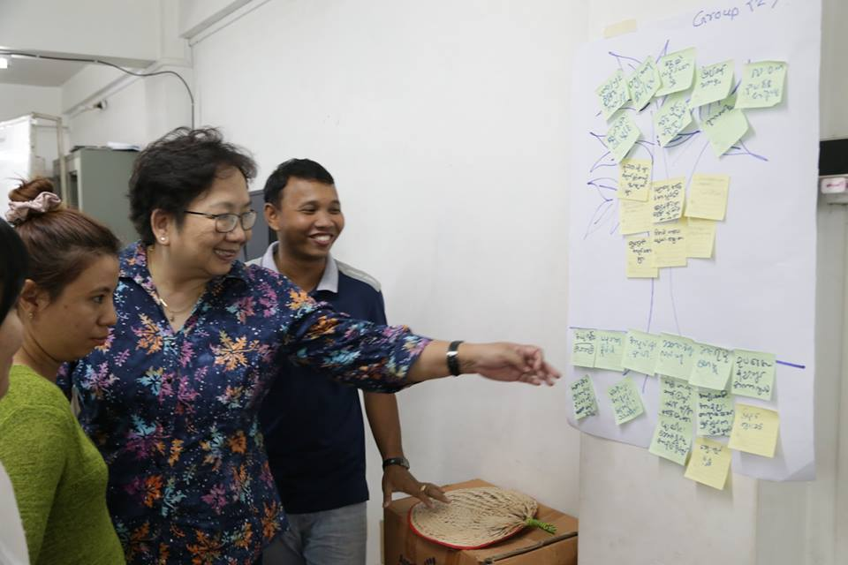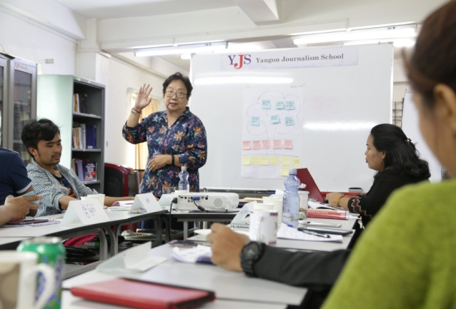

Activity Result 4.3: Increased engagement by private sector
- Though engagement with the private sector remained ad-hoc through 2018, UN-ACT has worked to establish connections with private sector partners and contribute to initiatives focused on strengthening private sector awareness of and response to human trafficking. As part of this, the Project Manager attended the Stakeholder Engagement Programme/Human Rights Due Diligence Workshop, Thailand. The included fieldwork with the Labour Rights Promotion Network, followed by sessions on Human Trafficking with IOM, NHRCT, Global Compact Network Thailand, Environmental Justice Foundation, and a dialogue session with JICA, UN-ACT, Winrock (USAID C-TIP), and Marimo-5. Kaori presented to the participants which included Japanese private sector on TIP and businesses and informed of UN-ACT’s work and how UN-ACT would be pleased to support them in their TIP/HR efforts.
- UN-ACT also participated in the October UNDP business and HR lab, providing consultation on migrant workers’ rights.
- UN-ACT also met bilaterally with several private sector stakeholders – including Facebook, Jones Day, IKEA, and the Japan Business and Human Rights Advocacy Group – to identify areas for collaboration and to provide advice on new private sector initiatives related to trafficking.
Development Approaches to Migration and Displacement
In August 2018, UNDP Bangkok Regional Hub published the ‘Development Approaches to Migration and Displacement in Asia Pacific’, which was the outcome of an initiative from UN-ACT, in collaboration with other partners in UNDP, at the regional and HQ levels. The structure of the approach and the strategy behind the policy brief, were driven in large part by the learnings from UN-ACT project implementation and reviews. The approach has developed out of a recognition that trafficking is occurring increasingly in the context of mixed migration patterns, as highlighted through the Anti-Trafficking Review collaboration. This initiative therefore situates UN-ACT’s counter-trafficking work within broader migration and displacement, which have been described as global megatrends of the 21st Century. The adoption of the SDGs and the development of two Global Compacts on Migrants and Refugees have placed these issues high on development agendas globally.
In applying a holistic development approach to migration and displacement in the Asia-Pacific region, the initiative aims to maximise the benefits of migration and mitigate the challenges of migration and displacement, by:
- Ensuring migration is a choice rather than a necessity, supporting alternatives where needed, and developing early warning systems and mitigation to displacement events;
- Empowering migrants and host communities, facilitating integration and social cohesion;
- Strengthening channels for migrants and diaspora communities within and from the region, to contribute to sustainable development in their home countries;
- Building the resilience of migrants and displaced persons to various vulnerabilities, including trafficking in persons; and
- Supporting the re/integration of migrants and displaced persons, helping to develop a range of services tailored to their needs.
The initiative has resulted in support for pilots at the national level in three countries (Indonesia, Philippines and Thailand), and with scope for expanding out further, dependent on resources. It is anticipated a more comprehensive concept note around this approach will be developed in 2019.

Resources Mobilisation: Efforts, Successes and Challenges
Besides planned activities, UN-ACT also worked to ensure the sustainability of activities related to the COMMIT Process secretariat role and the establishment of (T)NRMs, both through direct resource mobilisation efforts and through the establishment of cost-sharing models with partners. Collaboration with JICA, IOM, ILO, UNODC, Winrock International, and other partners, has meant that much more substantial and ongoing interventions have been supported through cost-sharing than through UN-ACT’s own resources. Our own resource mobilisation resulted in some successes – primarily through securing significant funding from a private foundation to fund UN-ACT’s NRM-related activities and through the establishment of new cost-sharing arrangements with COMMIT governments. Other applications for funding have been submitted to bilateral donor agencies and were in process as of 2018 end. Resource mobilisation efforts will continue into 2019 and will focus on integrating UN-ACT’s anti-trafficking work in the GMS within a holistic development approach to migration and displacement in the Asia Pacific. Funding limitations and the targeted nature of additional funding received meant that UN-ACT had to prioritise certain outputs in 2018 and increasingly moved towards provision of technical support, resulting in challenges at regional and country level.

Cross cutting issues

Gender
UN-ACT supported the COMMIT countries to put in place gender-responsive interventions, integrating gender-sensitivity into SPA IV implementation. In 2018, this was largely through the implementation of the (Trans)National Referral Mechanisms initiative, in providing gender-responsive assistance to trafficked persons.
UN-ACT provided technical and coordination support to finalise and conclude bilateral agreements to prevent and suppress trafficking in persons between the governments of China and Thailand and the governments of Myanmar and Thailand in 2018. As a result, the governments have highlighted in the Memorandum of Understandings the need to be aware and respect the rights and special concerns of women and girls in preventing the crimes and protecting trafficked persons.
In partnership with the ILO, UN-ACT published the research report “What’s the incentive? Comparing regular and irregular migrant work experiences from the Lao People’s Democratic Republic to Thailand” during the reporting period. The analysis in this quantitative study is gender-disaggregated throughout, revealing interesting gender dynamics and providing the evidence base for gender responsive programming on labour migration and trafficking between the two countries.
UN-ACT NPCs also provided inputs to the ASEAN Gender Sensitive Guidelines on for Handling Women Victims of Trafficking in Persons, through national consultation workshops.
In Vietnam, UN-ACT supported MOLISA in integrating gender into the development of the operational guidelines on referral and reintegration of trafficked victims. Government partners now recognize the similarities and differences in the experience of women, men and children trafficking victims and incorporate support services better-tailored to the needs of different gender and age group.

Human Rights Based Approach
Human trafficking is a severe form of human rights abuse whereby people are deprived of control over their lives. A human rights-based approach requires that interventions are designed with the objective to strengthen and protect people’s inherent rights, including through empowerment to claim such rights. UN-ACT’s activities seek to ensure that victims are empowered to regain control over their lives, while strengthening duty bearers’ capacities to respect, protect and fulfil the rights of vulnerable populations and trafficked persons.
In the GMS, it has been observed that interventions against human trafficking are widely dominated by law enforcement and security approaches, often with negative repercussions on human rights especially in women-dominated, informal sectors. More structural, empowerment-oriented responses to exploitation are needed. UN-ACT’s persistent advocacy and action for more coordinated and integrated counter-trafficking efforts over the years, including through collaboration with civil society, have contributed significantly to this effort.
Throughout 2018, UN-ACT has been able to continue proactively pursuing a human rights-based approach through its interventions, particularly with regards to the development of the (Trans)National Referral Mechanisms. These are based upon the COMMIT Guidelines for Victim Identification and Referral Mechanisms which prioritise a human-rights based approach, and integrates this throughout interventions, and development of the T/NRMs.

Challenges in Implementation
The most significant challenges faced at regional and country level related to limited funding for anti-trafficking activities, which – in Cambodia – affected UN-ACT’s profile and influence with government agencies, especially given that UN-ACT had to limit its role to technical support provision. In China, resources limitations contributed to postponement of the Senior Officials Meeting and also slowed progress towards implementation of (T)NRM implementation. In Thailand too, budget limitations led to the postponement of some activities
Other more specific challenges included:
- Discrepancies in legal frameworks between countries resulting in difficulties reaching and implementing bilateral agreements – for example differing definition of ‘victims of trafficking’ between Cambodia and China.
- A lack of justice for victims and ongoing lack of sustainable reintegration, despite increased focus on support and protection for trafficking persons by governments.
- At regional level, the division of responsibilities amongst ASEAN bodies working on TIP made engagement with partners beyond the GMS challenging. The distribution of responsibilities amongst ASEAN bodies – SOMTC, AICHR, ACWC – make engagement of ASEAN costly and time consuming.
- In Vietnam, government restructuring which resulted in transition of government focal points for anti-trafficking related matters slowed UN-ACT activities
- Staff rotation within UN-ACT country offices also meant programming was slower than anticipated, particularly in Myanmar.
Lessons learned:
UN-ACT continued to face budget constraints in 2018 that impeded more substantial implementation of our approach to supporting collaboration, cooperation, and developing capacities in counter-trafficking in the sub-region. With the support of the Government of Sweden, UN-ACT was able to continue implementing and undertake a bridging period as the project sought to elaborate on the direction beyond the current phase. The annual workplan was adopted later than normal due to the transitional phase of the project, but we were able to overcome budgetary constraints through joint implementation with other development partners, contributing technical expertise and convening power, cost-shared with other partners, and encouraging COMMIT governments to use more of their national budgets to fund activities.
Bilateral cooperation has been one of the key achievements between COMMIT countries, however the governments also recognized challenges that undermine the effective implementation - such as differences in legal frameworks, language barriers, lack of resources, and capacity of law enforcement officials and communities at the local level in counter-trafficking.
The understanding of and respect for human rights in the sub-region remains weak. This compounds the tendency of governments to prioritize law enforcement and national security-oriented approaches to counter-trafficking, meaning advocacy for victim-cantered approaches remains challenging. While policies and laws have been developed in this context, their implementation is weak for a range of reasons. Human trafficking is often made a national priority by governments in the region when expedient politically, and rarely planned and resourced to make a significant impact on the problem, especially where it relates to broader systemic labour issues. As the phenomenon largely impacts the powerless and weak in society, there is little incentive for those in power to address their concerns, especially given inadequate democratic decision-making procedures. This will continue to require the advocacy efforts of international organisations supporting civil society and working with governments to address.
Through the COMMIT Process, UN-ACT seeks to provide a vital platform for systematic civil society engagement and collaboration with governments. This includes in the design and implementation of anti-trafficking laws and policies. Yet, civil society space is still limited in some of the COMMIT countries. The governments recognize there are difficulties in officially engaging with CSOs as they are not officially recognized by law in some of COMMIT countries (For example in Vietnam, CSOs have to register under government agencies for their daily operations). This is however not a linear process or relationship, and progress that is made, as well as partnerships, may also regress.

The Way Forward
UN-ACT will continue to transition towards a broader focus on Development Approaches to Migration and Displacement, in collaboration with the specialists and advisors within UNDP working on related issues. This is particularly the case with the Disaster Risk Reduction practice area, given the increasing need to focus on displacement of people as a result of disasters, and how this is also impacted by slow- and sudden-onset climate events.
Over 2019 it is anticipated that the NRM initiative will further ensure the sustainability of UN-ACT’s support to the COMMIT Process. The Senior Officials Meeting in China, now planned for the first quarter of 2019 will help to further this initiative and also the sustainability of the COMMIT Process.
Resource mobilisation will continue to be required for these efforts. If this is not successful then UN-ACT will transition to a smaller structure focused on COMMIT sustainability and ensuring the delivery of the activities committed to partners through to June 2020.

Annex I: List of Acronyms
ACWC: ASEAN Commission on the Promotion and Protection of the Rights of Women and Children
ASEAN: Association of Southeast Asian Nations
AICHR: ASEAN Inter-Governmental Commission on Human Rights
COMMIT: Coordinated Mekong Ministerial Initiative against Trafficking
GMS: Greater Mekong Sub-region
HRBA: Human Rights Based Approach
ILO: International Labour Organization
IOM: International Organization for Migration
Lao PDR: Lao People’s Democratic Republic
DMD: Development Approaches to Migration and Displacement
M&E Monitoring and Evaluation
MOU: Memorandum of Understanding
NGO: Non-Governmental Organization
RBM: Results-Based Management
SOM: Senior Officials Meeting
SOP: Standard Operating Procedure
SOMTC: ASEAN Senior Officials Meeting on Transnational Crime
SPA: Sub-regional Plan of Action
T/NRM: (Trans)National Referral Mechanisms
TWG: Technical Working Group
UN-ACT: United Nations Action for Cooperation Against Trafficking in Persons
UNDP: United Nations Development Programme
UNIAP: United Nations Inter-Agency Project on Human Trafficking
UNHCR: United Nations High Commissioner for Refugees
UNODC: United Nations Office on Drugs and Crime
UNTOC: United Nations Convention against Transnational Organized Crime

Information gathered as part of UN-ACT’s review of bilateral cooperation mechanisms.
Information self-reported by governments via UN-ACT National Project Coordinators as part of COMMIT Process monitoring – NB: this only includes figures for Cambodia (848), Vietnam (340), and Thailand (401). Figures for China, Myanmar and Lao PDR are yet to be reported by government counterparts.
Capacity mapping, budget advocacy, and national consultations were all either led or supported by UN-ACT personnel.
Feedback from government officials given to UN-ACT National Project Coordinators regarding recommendations for policy and tools for frontline law enforcement and service providers that resulted from activities related to the NRM initiative.
Information self-reported by governments via UN-ACT National Project Coordinators as part of COMMIT Process monitoring – NB: this only includes figures for Cambodia and Vietnam. Figures for China, Myanmar, Lao PDR, and China are yet to be reported by government counterparts or still being verified.

